Google Drive
To register your application in Google Drive, follow the instructions below.
- Go to the Google Developers Console by link: https://console.developers.google.com/,
select the item: Google Cloud Storage.
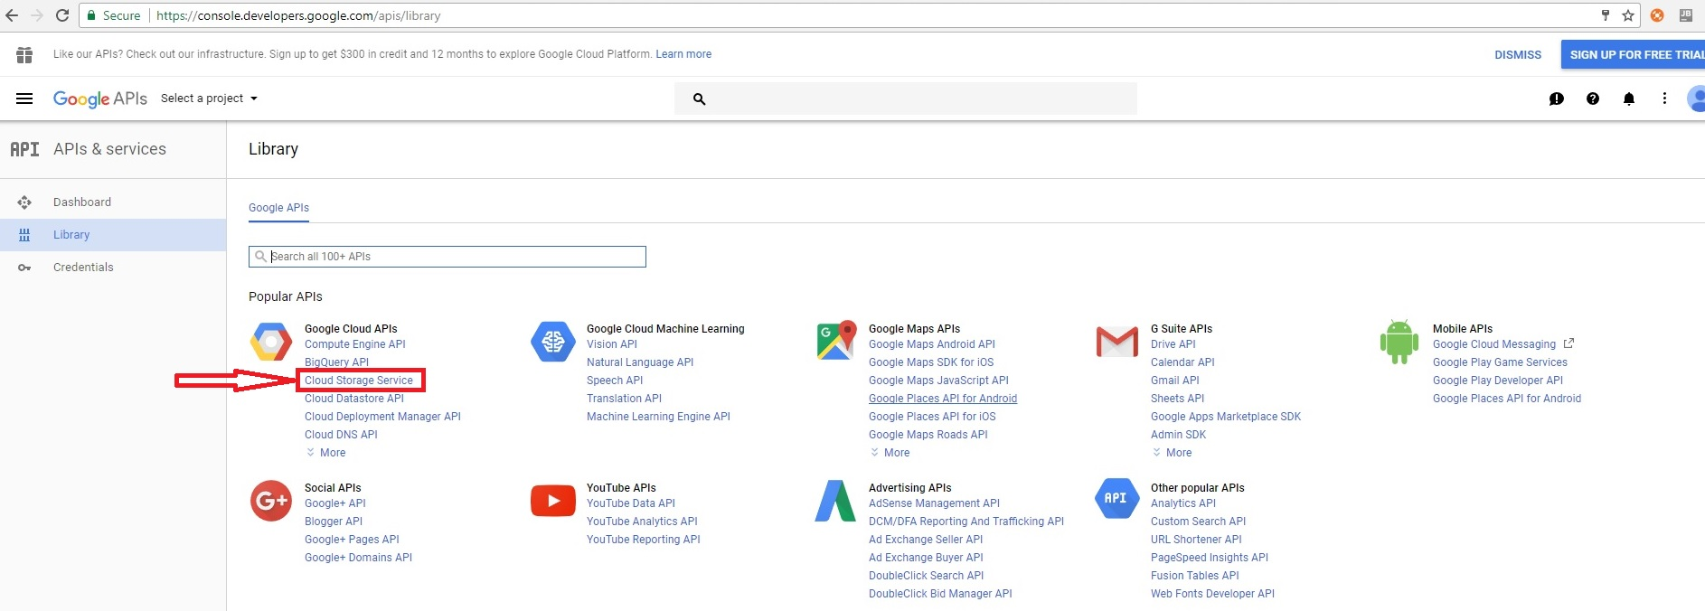 The confirmation: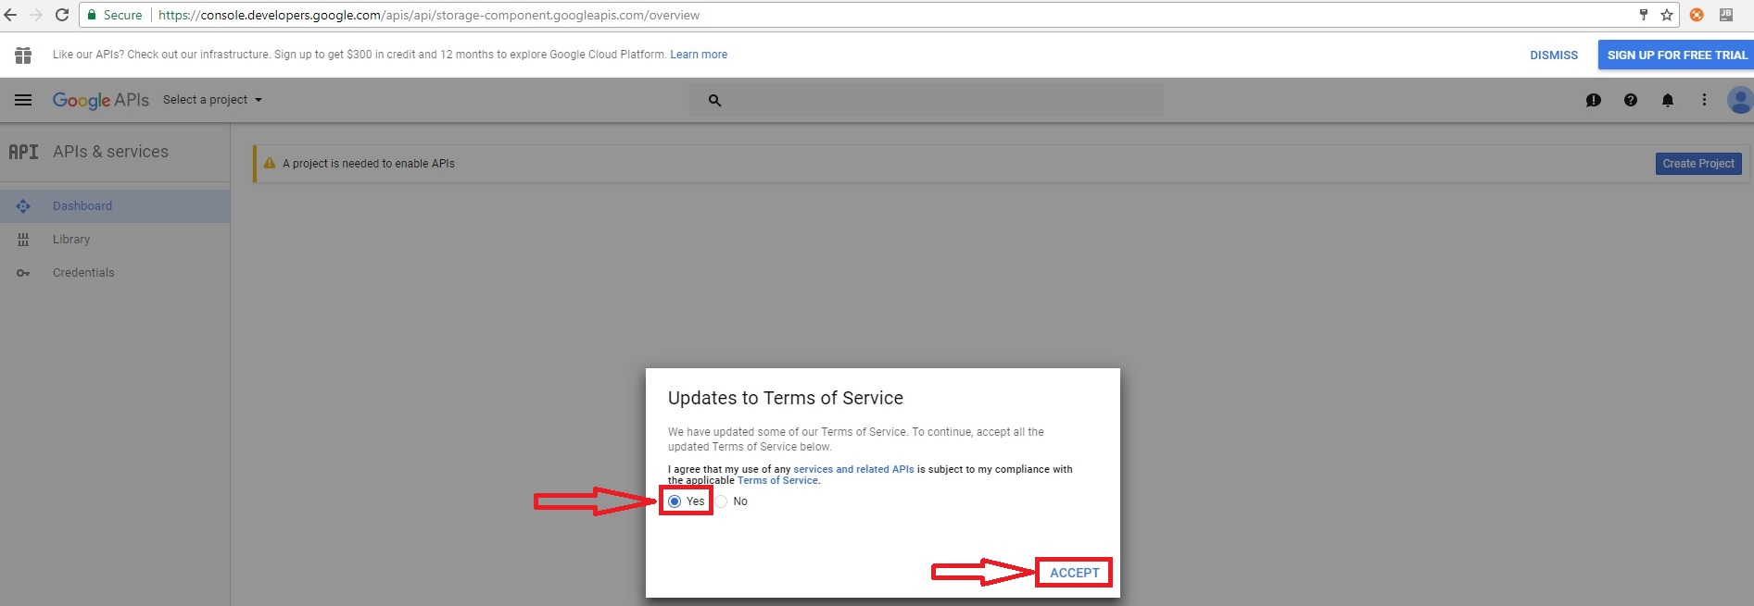

2. Click on the button «Create a project».
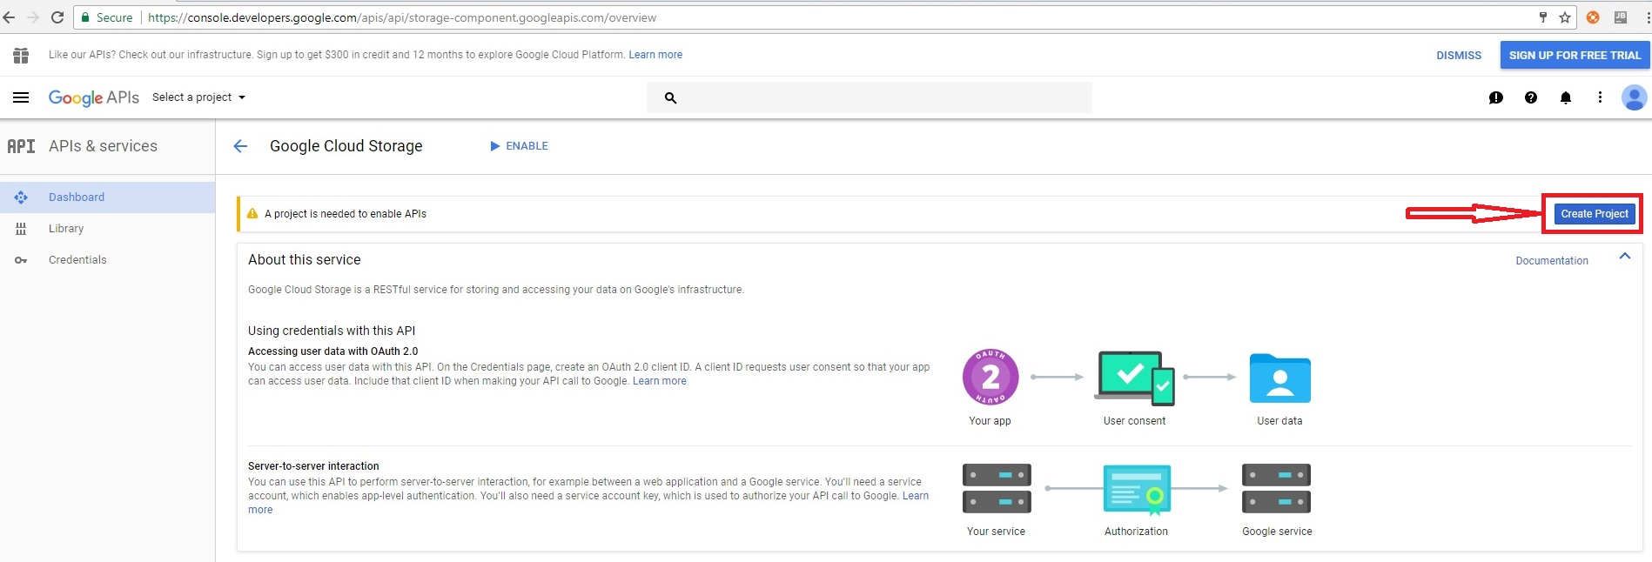

3. Confirm the creation of the project.
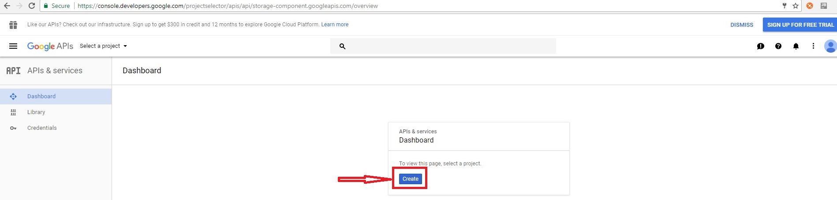

4. Enter the name of your project (for example, we used the name bNesisTest) and click on the Create button. When you enter a project name, the Project ID is assigned automatically.
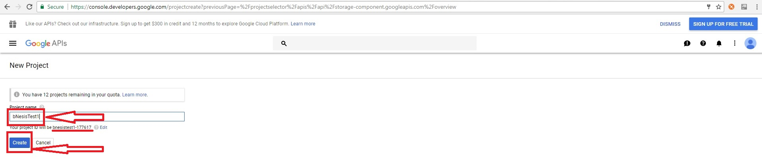
5. Press the "Enable" button.
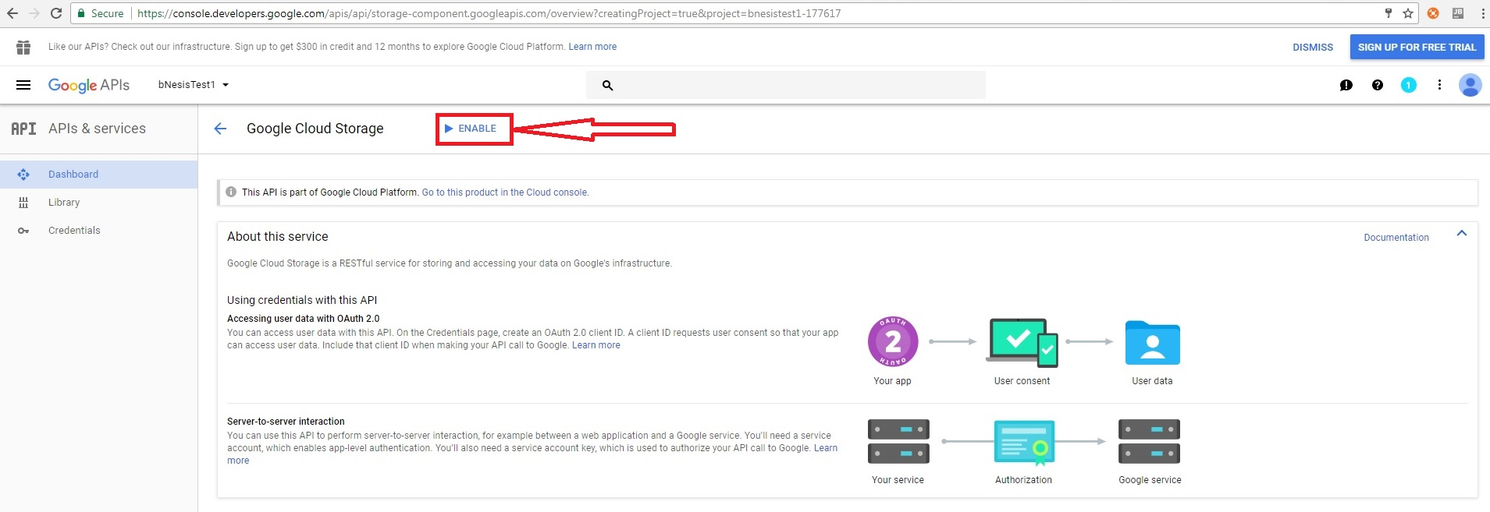
6. Next we create credentials.
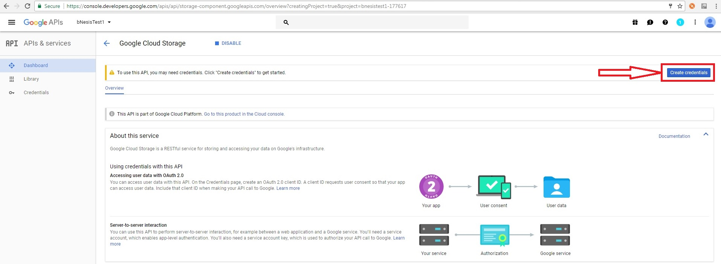
7. Adding credentials.
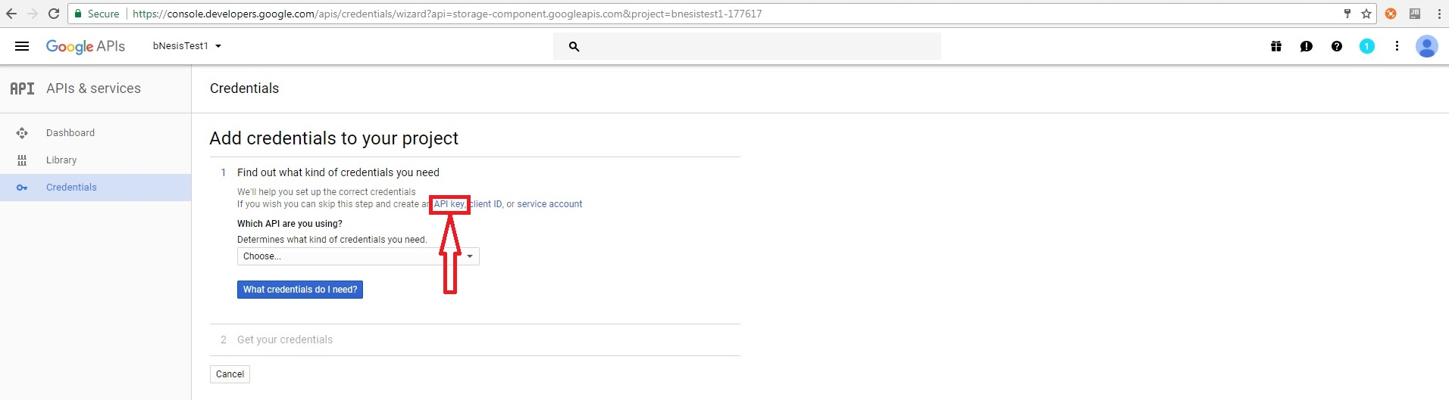
8. Creating an API key.
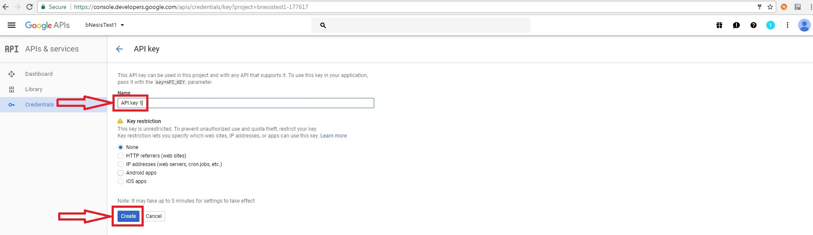
9.
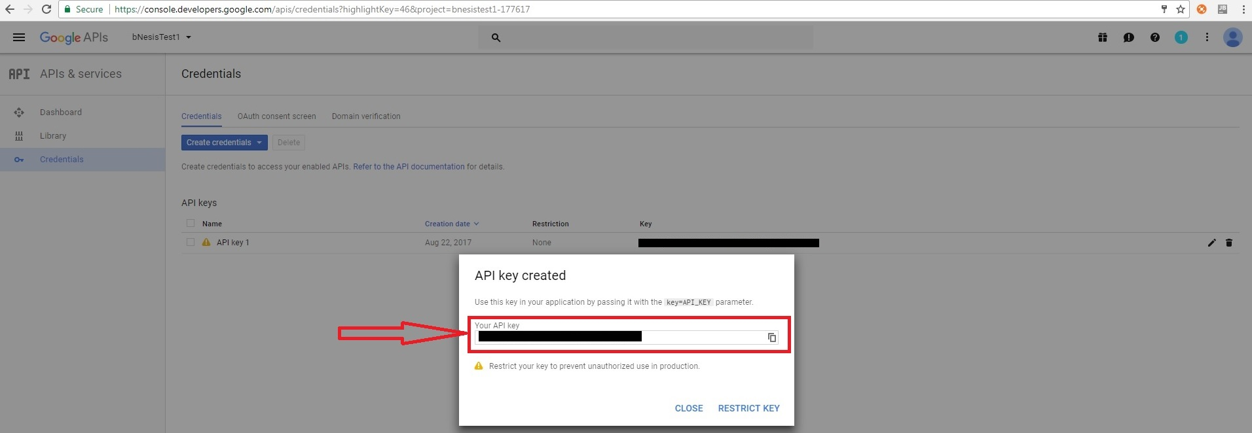
10. Select OAuth client ID to create an Identifier and Secret client for OAuth authorization. Click on the button "Configure the access request window".
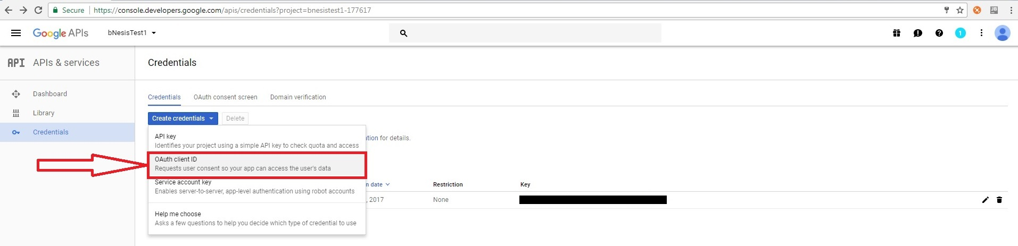
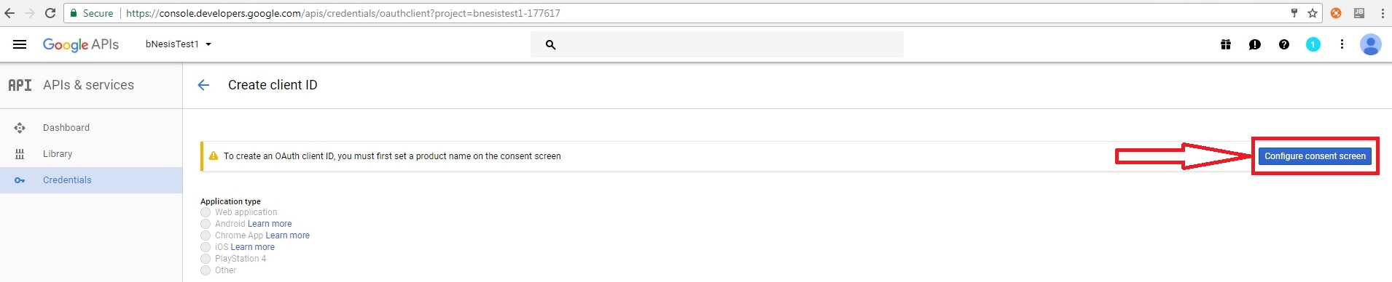

11. Obtaining the Customer ID and the customer secret. Select Application Type, Name, Allowed JavaScript Sources, Redirect URI. And click on the Create button.
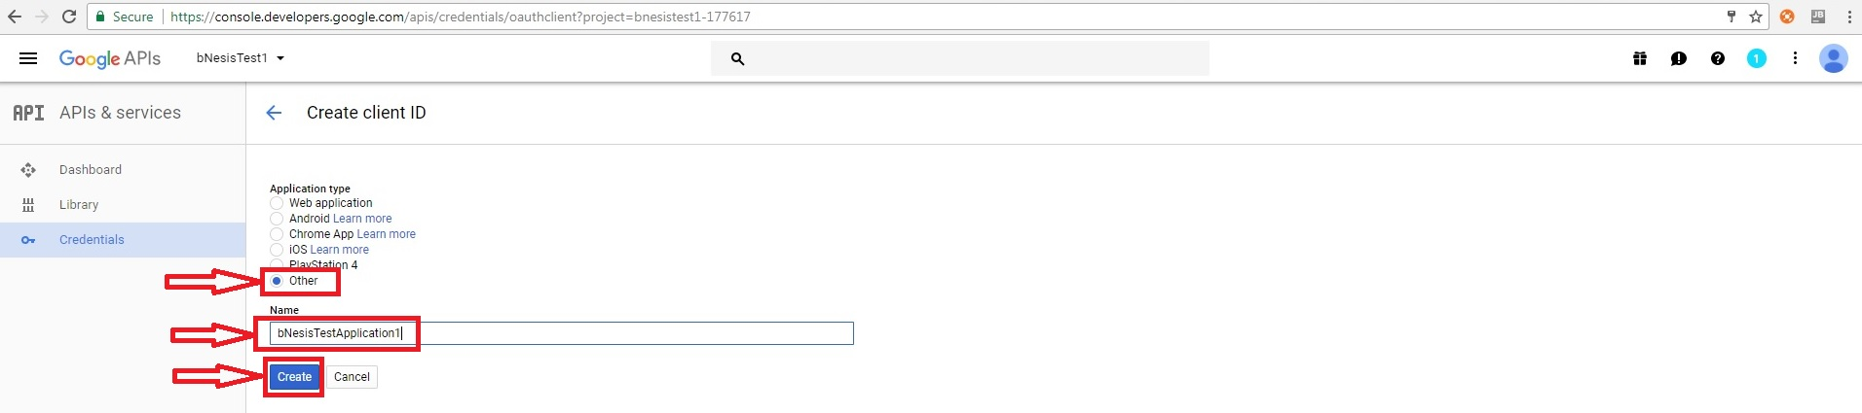
12. After the creation, a window with your client ID and Secret for OAuth authorization will be displayed.
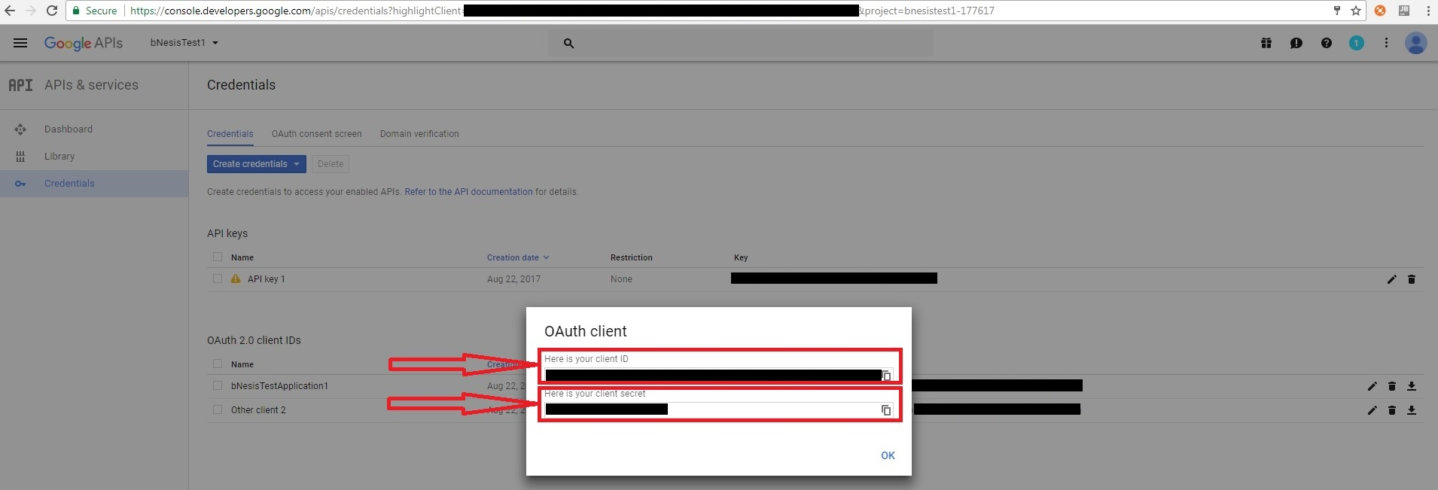

13. The client ID for OAuth 2.0 can be viewed by clicking on the name of this identifier.

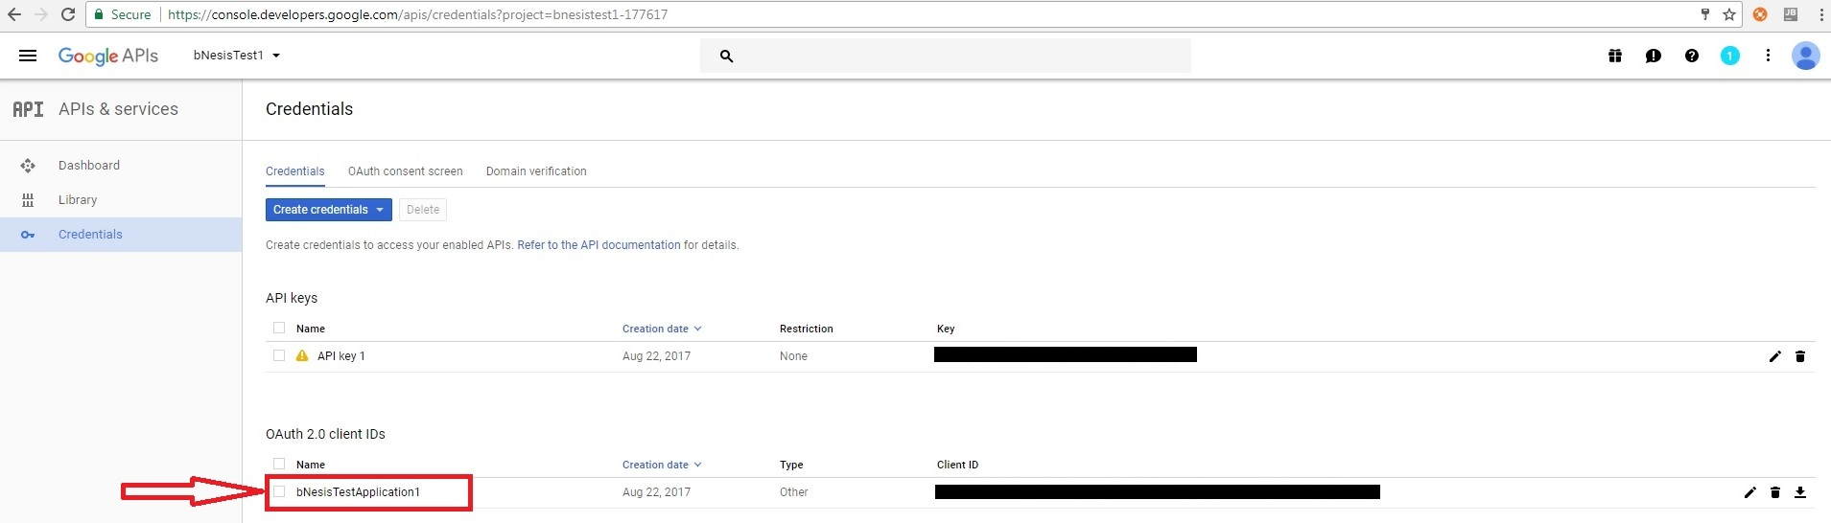
14. Copy your Customer ID and Client Secret to the bNesis application.
